***Common Core Performance Task – +2 extra credit test points for showing all work on extra paper***

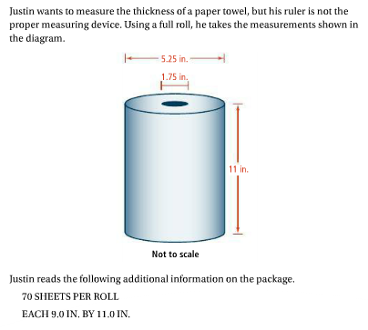

Screen%20Shot%202018-04-18%20at%209.23.28%20AM.png

***Drawing - + 5 extra credit classwork points for drawing on a separate piece of paper***

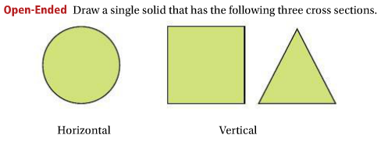

***January Regents Questions – Extra Credit +1 HW Point each – show ALL work***

